## Challenge 2: Simple SciBorg Behaviors

**1.** **bounce**: Write a program that makes your *SciBorg* go forward until it bumps into an obstacle, then back up for one second.

**2. escape**: Program *SciBorg* to find its way out of a field of obstacles. The random procedure is quite helpful here.

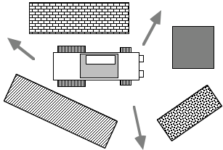

**3. going the distance:** Program your *SciBorg* to drive a distance of 1.5 meters over various terrain. Use three different approaches based on 1) elapsed time, 2) feedback from the counters, 3) using a reflectance sensor to detect when you’ve reached the “finish line”. Which approach works best?