# LEGO Mechanisms: Gears and Motors

A **motor** converts electrical energy into mechanical movement.

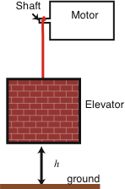

Try grabbing onto a spinning LEGO motor. Can you make it “stall”? Compare the behavior of the “old gray motor” and the “new gray motor”.

There is a:

**“Stall Avoidance” vs. speed *tradeoff***

The concept of **tradeoffs** is one of the “big ideas” of engineering.

More technically: A given motor is capable of providing a certain maximum amount of **torque** before stalling. (“Torque” is a measure of the motor’s ability to cause an object to spin, much as “force” is a measure of ability to cause an object to move.) So when designing a motor there is a fundamental:

**torque vs. speed *tradeoff***

# Building a Gear Train

We can use **gears** to change the amount of torque supplied by a motor. (Inevitably the speed at which the output shaft spins will change as well.)

Use axles, beams, and gears to build a simple gear system using an 8-tooth gear and a 24-tooth gear:

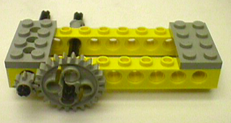

Try rotating the shaft with the small gear with your fingers. Note that the relative rate of rotation of the two axles is different, by a factor of three, which is equal to the ratio of number of teeth on the gears (24:8).

**Question:** What’s the difference between the old and new LEGO motors?

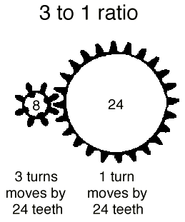

When the 8-tooth gear rotates 3 times, it advances the meshed gear by a total of 24 teeth. Since the meshed gear has a total, it rotates exactly once. (We say this configuration has a 3:1 **gear ratio**.) Thus the 24-tooth gear rotates *three times slower* than the 8-tooth gear.

*Going* ***from small*** *gears* ***to big*** *gears* ***lowers******the speed*** *of rotation by a factor equal to the gear ratio.*

**Let’s Talk About Torque**

Try opening a door. How easy it is to open depends on 1) *How hard* you push and 2) *where* you push.

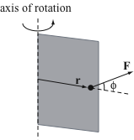

Mathematically:

torque = r x F

What about our gear train?

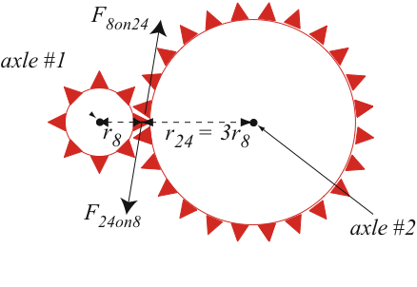

Since torque = r x F, the torque about axle #2 is three times greater than the torque about axle #1; the gear train acts as a **“torque amplifier”**.

*Going* ***from small*** *gears* ***to big*** *gears* ***increases******the torque*** *by a factor equal to the gear ratio.*

**Gear Trains: Ganging Gears**

Here’s an absolutely brilliant trick:

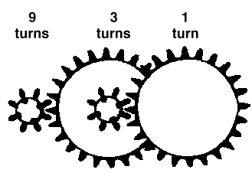

By “ganging together” – or multiplying – two 3-to-1 gear reductions, a 9-to-1 output reduction can be achieved. The key is to use intermediary shafts that hold both a large input gear (e.g. a 24-tooth) and a small output gear (e.g. an 8-tooth).

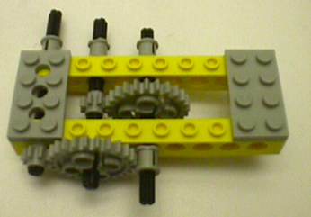

So now the torque at the “output shaft” is 9 times the torque provided on the left (‘input”) axle. The output shaft will of course spin 9 times slower than the input shaft, but it will be much harder to stall!

Of course, once you have discovered a great idea, you might as well keep using it!. Try building an additional stage of gear reduction:

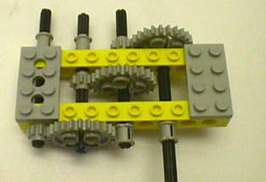

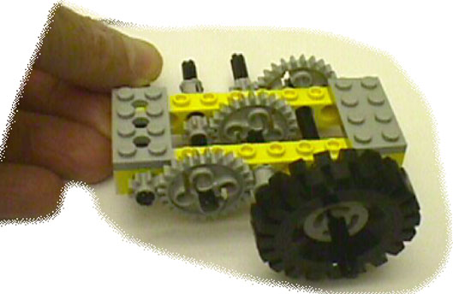

**Gear Train Building Tips**

* **adjust the “bushings”** so they’re not too tight, not too loose.
* build a **square and rigid frame** so that the holes in the beams remain lined up.
* **support the axles** in at least two places so that they don’t bend.
* The LEGO gears are sized so that they mesh nicely in “horizontally” aligned holes as shown above. (Note: This works because an 8-tooth gear has a radius of 0.5 FLU and a 24-tooth gear has a radius of 1.5 FLU.)

# Getting Geared Up

**Radii of gears:**

8 tooth = 0.5 FLU

16 tooth = 1.0 FLU

24 tooth = 1.5 FLU

40 tooth gears = 2.5 FLU

By use of plates, it is also possible to mesh gears in the vertical direction:

## 

# LEGO Motor Varieties

**Red “micromotors”** – relatively low power but high torque, since they have internal gearing inside the red box (amazing!)

**Old Gray Motors** - Much higher power than the micromotors but output shaft is high speed / low torque. You need to build gear trains to use them!

**New Gray Motors** (Gear Reduction Motors) - The best of both worlds! Similar in power to the old gray motors, but with internal gearing so that the output shaft speeds at a decent rate with lots of torque. You’ll need less in the way of gear trains when you use them!

**Newest Clear Motors** - Similar to the new gray motors in performance; the transparent case lets you see the internal gear train. They lack the awkward “hump” found on the new gray motors, and hence a bit easier to build with.

## Challenge 8: Single Motor Racing Vehicle

In a group with two or three members, design a vehicle with a single motor, powered by a *PicoCricket,* that can carry a 1.0 kg weight as fast as possible on a 3 meter course. You should use one of the *old* gray rectangular motors that does *not* have internal gearing. This will force you to experiment with building your own gear trains.

This is a non-trivial challenge that will require many design iterations on your part. You will have several days to work on this challenge. There will first be a test run in which you will pit your vehicle against others on the 3 meter course. On the following day final competitive event will be held. You should document each iteration of your design in your design journal.