Laboratory 10

Control Path,Single-Cycle and Pipelined CPU

Computer Science 240

In the last lab, you used LogicWorks to design and implement all the main components of the datapath for the Mini-MIPS machine. In this lab, you will also investigate how to produce the control signals for the machine. You will then be able to observe the operation of the completely connected single-cycle CPU, by writing and executing some small programs.

ALU Control Unit
Exercise 1: The ALUop bits (which control the operation of the ALU) are not the same as the opcode (which specifies which instruction is being executed). It is necessary to design an ALU Control Unit to translate the opcode to the proper ALU operation for each instruction.

The ALU Control Unit for the Lab machine is somewhat simpler than the one discussed in lecture. Here is the truth table:

Instruction Opcode ALU operation ALUop
LW 0 add 2
SW 1 add 2
ADD 2 add 2
SUB 3 sub 6
AND 4 and 0
OR 5 or 1
SLT 6 slt 7
BEQ 7 sub 6
JMP 8 don’t care don’t care

So, you must design a circuit for the following:

Op3 Op2 Op1 Op0 ALUop3 ALUop2 ALUop1 ALUop0
0 0 0 0 0 0 1 0
0 0 0 1 0 0 1 0
0 0 1 0 0 0 1 0
0 0 1 1 0 1 1 0
0 1 0 0 0 0 0 0
0 1 0 1 0 0 0 1
0 1 1 0 0 1 1 1
0 1 1 1 0 1 1 0

Use a 3x8 decoder to produce the ALUop bits. Implement in LogicWorks , test, and demonstrate to the instructor. Paste your design here:

Control Unit
Exercise 2: The control lines can be produced as a simple function of the opcode, as defined in the following table:

Instruction Opcode RegDst RegWr ALUSrc MemRd MemWr MemtoReg
LW 0000 1 1 1 0 1 1
SW 0001 1 0 1 1 0 0
ADD 0010 0 1 0 1 1 0
SUB 0011 0 1 0 1 1 0
AND 0100 0 1 0 1 1 0
OR 0101 0 1 0 1 1 0
SLT 0110 0 1 0 1 1 0
BEQ 0111 0 0 0 1 1 0
JMP 1000 0 0 0 1 1 0

Write a function for each control line, or use a decoder to produce the signals. Paste your design here:

Exercise 3: Open the datapath1.cct circuit sent to you prior to lab. Close the timing window and parts palette to view the full circuit:
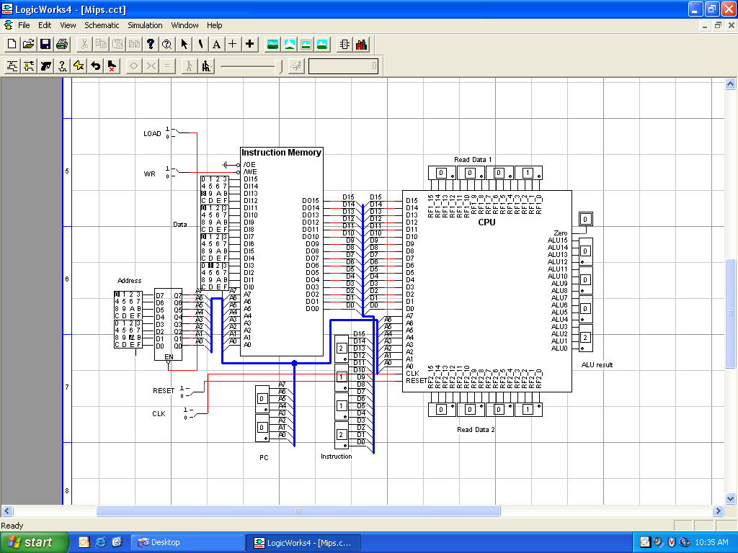

The CPU has been abstracted to a black box, and is connected to the Instruction Memory, where programs must be loaded prior to execution by the CPU. You may recall from an earlier lab that the LOAD, WR, data, and address switches on the left are used to load a program into Instruction Memory.

The PC and Instruction LED displays on the bottom left show the address in Instruction Memory currently being executed, and the instruction itself.

The Read Data 1 and Read Data 2 register file ports and the ALU result from the CPU are also displayed. These can be used to verify correct execution of instructions.

The Reset and CLK switches on the bottom left are used to control execution of a program in the CPU.

The circuit you uploaded contains a short program you have seen before in binary form. Fill in the table below for each instruction in the program, explaining what the instruction does :

Address Instruction operation Rs Rt Rd/offset Purpose
0: 5002

2: 5003

4: 1220

6: 0230

8: 2122

A: 8002

Does this program ever stop?

Execute the program by performing the following steps:

- Set the Reset switch to 1 and back to 0.

Notice that the PC goes to 00. What does this mean?

What value is displayed on the Instruction LED? What is this value?

What values are displayed on Read Port 1, Read Port 2, and the ALU Result? What do these mean?

- Set the CLK switch to 1 and back to 0. You just executed the first instruction, and stored the ALU Result to the destination register (in other words, R0 OR R0 = 0 -> R2).

What is the value of PC now? Why?

What value is displayed on the Instruction LED? What is this value?

3. Set the CLK switch to 1 and back to 0 to execute this next instruction. You have now cleared both R2 and R3.

What is the value of PC now?

You are now at the start of the loop in the program For the next 16 instructions, toggle the CLK switch and record the values you observe in the table below (for each instruction, only record the values that change for that instruction):

PC Inst. R2 R3 Addr. 0 Addr. 1 Addr. 2 Addr. 3
0 0 ? ? ? ?
4 SW R2 R2 0 _______

_______

_______

_______

_______

Exercise 4: Assume two values are stored in data memory at address 0 and 2. The following program will subtract the value at address 2 from the value at address 0, and store the result in address 4 (the first five instructions place values into address 0 and address 2 in the data memory).

Fill in the hexadecimal value for each instruction in the table below:

Address Instruction op Rs Rt Rd/offset Purpose
0: ADD R1 R1 R2 ; R2 = 2
2: ADD R2 R2 R3 ; R3 = 4
4: ADD R3 R3 R3 ; R3 = 8
6: SW R0 R3 0 ; data address 0: 8
8: SW R0 R2 2 ; data address 2: 2
A (LOOP): LW R0 R5 0 ; R5 <- 8 from address 0
C: LW R0 R4 2 ; R4 <- 2 from address 2
E: SUB R5 R4 R5 ;R5<- 8 – 2 = 6
10: SW R0 R5 4 ;data address 4: 6
12: LW R0 R15 4 ;R15 <- contents of address 4
14: OR R15 R15 R15 ; displays contents of R15 at ALU result
16: BEQ R2 R15 LOOP ; repeat the instructions starting at label loop
18: J END ; jump to end of program
…
30 (END):

Fill in the table below with the predicted values for the registers and data memory after each step (for each instruction, only record the values that change for that instruction):

PC Inst. R2 R3 R4 R5 R15 Addr. 0 Addr. 2 Addr. 4
0 0 0 0? 0 ? ? ?
0 2112
2 2223
4 2333
6 1030
8 1022
A 0050
C 0042
E 3545
10 1054
12 00F4

To load the Instruction Memory with this program, follow these steps:

- Disconnect the address bus of the Instruction Memory from the CPU (ask the instructor to demonstrate how to do this).

- Set LOAD = 0

- Set address and data switches for instruction

- Set WR = 0, then back to 1

- Repeat steps 3 and 4 until all instructions are loaded to memory

To execute the program, follow these steps:

- Set LOAD = 1

- Reconnect address bus to CPU

- Set Reset = 1, then back to 0

- Set CLK = 1, then back to 0, for each instruction. Stop when the PC = 14.

Do you see the value of 6 displayed at the ALU Result? Demonstrate to the instructor.

Close the circuit before the next exercise.

Pipelining
Exercise 5: The following diagram shows the single-cycle datapath for the mini-MIPS lab machine:

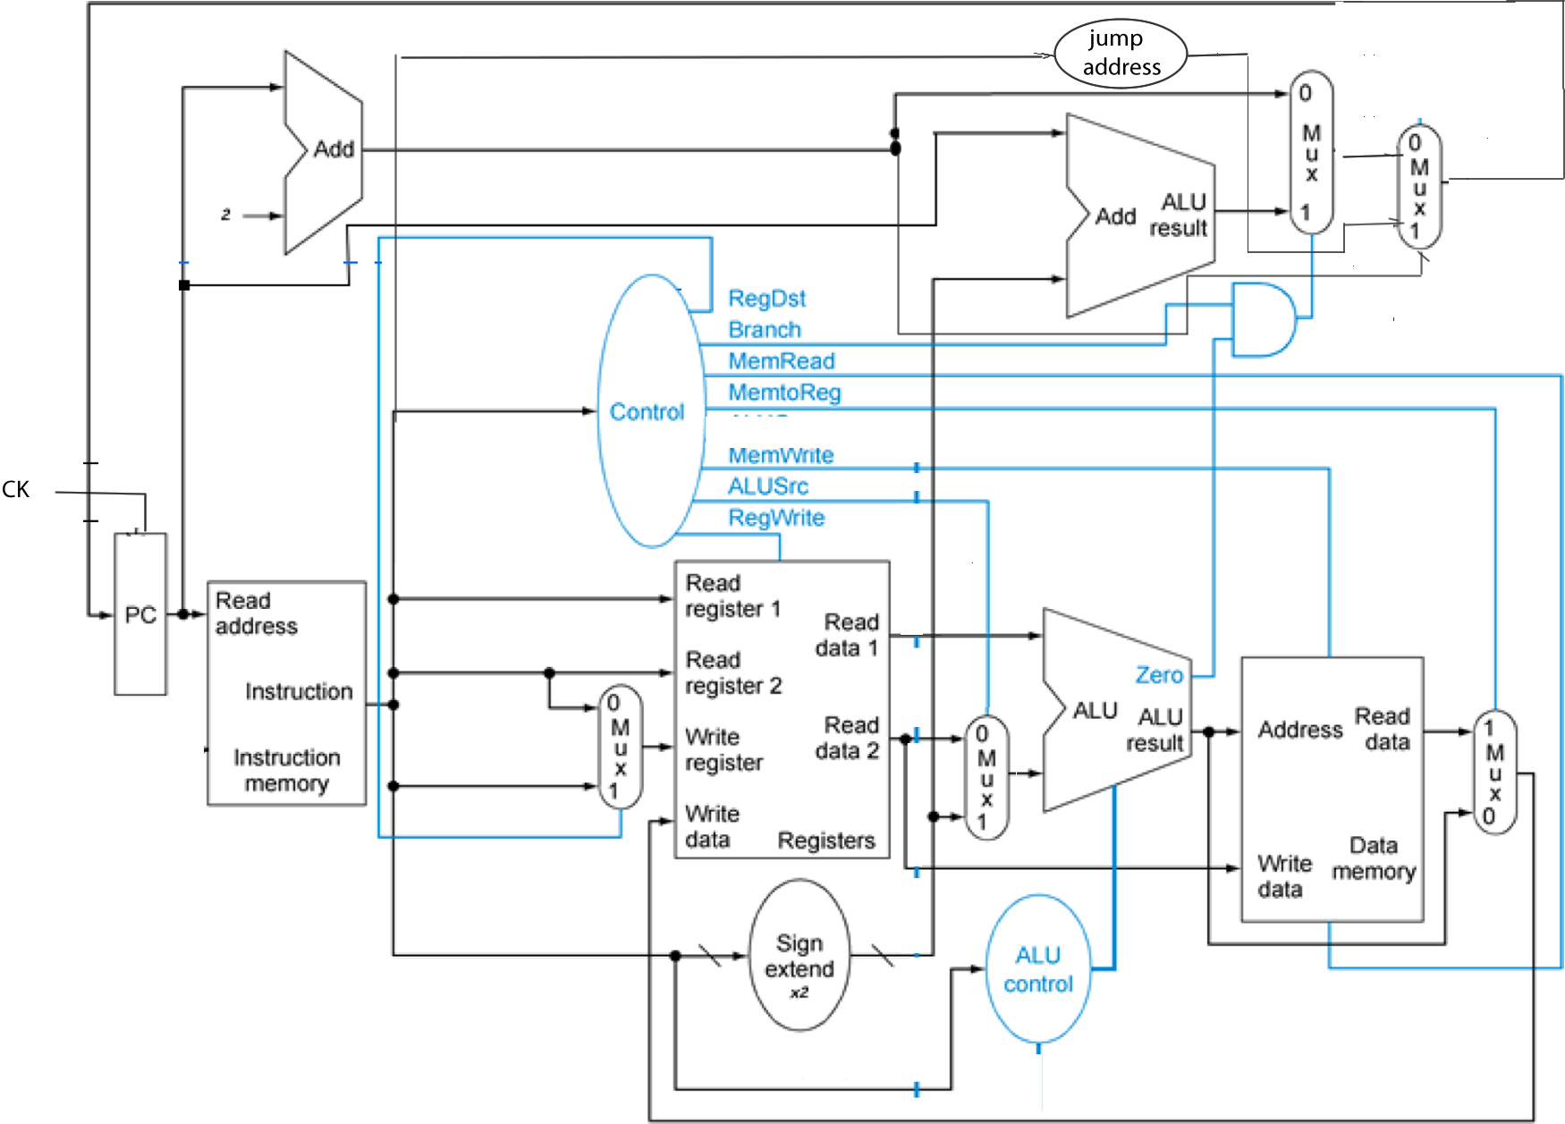

As you have learned in lecture, this machine executes one instruction per clock cycle. The clock cycle must be long enough for the instruction with the longest path (critical path) , which is the lw. Since many of the instructions executed in a typical program have a shorter path than the lw, the single-cycle datapath is inefficient (it wastes time during the shorter instructions).

To increase efficiency, it is possible to divide the datapath into stages, and execute multiple instructions in parallel. Assuming a large number of instructions are executed, this results in a speed-up proportional to the number of stages, which is a big improvement in efficiency. This is called a pipelined datapath.

In the pipelined Mini-MIPS machine, the following stages are used:
1. Instruction fetch (get the instruction from memory)
2. Instruction decode/register file access (use the instruction to get the control signals and operands)
3. Execution/ALU (use the operands and control signals to perform an operation in the ALU)
4. Data memory access (access the memory if necessary)
5. Register file write-back (write back the result to the register file)

Each stage is separated from the next by a set of registers, which store the results and control signals from the stage and send them to the next stage on each clock pulse. The following page shows the mini-MIPS pipelined datapath (hazards are not taken into consideration in this design). This diagram is similar to the MIPS pipeline from the textbook, with a few modifications to correspond to the differences between the text and lab machine:
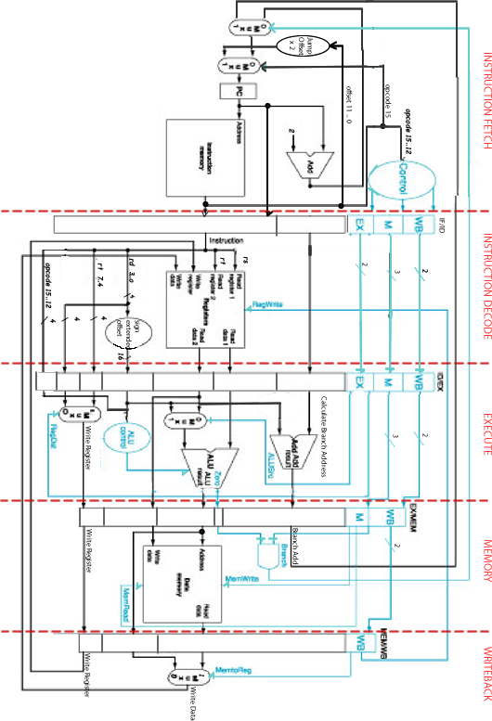

Open the pipeline.cct circuit from the Google group. Examine the circuit, to verify that you understand the modifications which have been made to implement pipelining.

The Instruction Memory is preloaded with a testing program which does not contain any hazards.

1. For each instruction, predict the value of the ALU and any registers or data memory locations that are modified by the instruction:

PC/Address Instruction ALU Register Data Memory Address: Value
00: SW R0 R1 0
02: ADD R1 R1 R2
04: SLT R0 R1 R3
06: SUB R1 R0 R4
08: ADD R1 R1 R5
0A: LW R0 R6 0
0C: ADD R1 R1 R7
0E: SLT R0 R1 R8
10: SUB R1 R0 R9
12: ADD R1 R1 RA
14: ADD R6 R6 RB
16: BEQ R0 R0 7
18: OR R3 R3 R3
1A: OR R4 R4 R4
1C: OR R5 R5 R5
1E: OR R6 R6 R6
20: .
22: . no instructions stored here
24: .
26: JMP 00 00 00

You will run the program (don’t do it yet!) by pulsing the reset to 1 and back to 0, and then pulsing the clk to 1 and back to 0 to execute a stage of the pipeline. You will be able to understand the progress of your program by monitoring the displays at the bottom left of the circuit. Each set of displays represents a stage of the pipeline, and is labeled appropriately.

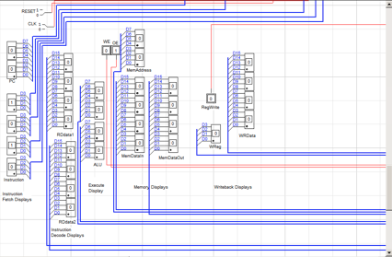

2. Predict (don’t operate the circuit yet) values of the pipeline stages for the first instruction SW R0 R1 0:

Instruction  Fetch  (reset) | Instruction  Decode  (1st clk ) | Execute  (2nd clk) | Memory  (3rd clk) | Writeback  (4th clk)
PC = 00
Inst = 1010
RDd1 =
RDd2 =
 |  | ALU=
MemAdd=
MemDin=
MemDout=
RegWrite=
WReg=
WRData=

Does it matter what MemDataOut is for this instruction?

Does anything happen in the Writeback stage for this instruction (in other words, does a value get written back to a register in the register file?)

3. Also predict the values of the pipeline stages for the second instruction (ADD R1 R1 R2). Notice that the table of values here is offset by one clock cycle from the first instruction (which is how the pipeline works).

PC = 00
Inst = 1010
RDd1 = 0000
RDd2 = 0001
 | PC =  Inst = |  | ALU= 0000
 |  |  | RDd1 =  RDd2 = | MemAdd= 00  MemDin= 0001  MemDout= xxxx
 |  |  |  | ALU = | RegWrite= 0  WReg= xx  WRData= xxxx
MemAdd=
MemDin=
MemDout=
RegWrite=
WReg=
WRData=

Does it matter what the values are in the Memory stage for this instruction? How about the Writeback stage?

Exercise 6: Execute the program in memory, and record the values on the displays after each clock cycle (use a small font, it is important that the cells stay aligned!):

At this point, you should be at the JMP 0 0 0 instruction, which should take you back to the beginning of the program.

2. Did you notice that for the BEQ R0 R0 7 instruction, even though the branch condition was met (R0 = R0), two more instructions entered the pipeline before the branch was taken? Examine your output to verify this, and mark the two cycles where these instructions entered the pipeline.

For this particular program, this does not cause a problem, since those two instructions make no changes to any of the registers. But, normally, this is a problem called a branch hazard, which you learned about in lecture. There are several modifications which deal with branch hazards, including calculating the branch address and evaluating the condition earlier in the pipeline.

Data Hazards
Exercise 7: The test program you are using does not have any data hazards, which are when one instruction needs the result of an instruction either one or two cycle earlier. In this case, the instruction is still in the pipeline (is not yet complete, so that the value has not yet been written back to the register which is needed).

1. For example, for the first five instructions:
00: SW R0 R1 0
02: ADD R1 R1 R2
04: SLT R0 R1 R3
06: SUB R1 R0 R4
08: ADD R1 R1 R5

changing the third and fourth instructions to:

04: SLT R0 R2 R3
06: SUB R2,R0,R4

would both cause a data hazard and incorrect final results for R3 and R4. Why?

However, changing the fifth instruction to:

08: ADD R1 R2 R5

(which also uses R2) would work correctly. Why is this okay?

2. Modify the three instructions as indicated in the previous step, and reset the circuit. Clock until you see that the result in R3 is incorrect (it will take 6 clock pulses to view the incorrect result be written to R3, although you can see by reading the displays in the earlier stages that R2 has not yet been updated to 2 when it is used in the SLT instruction).

3. Clock again to view the incorrect result for R4.

4. Clock once more to view the correct result for R5.

To solve this problem, you can forward the value as soon as it is available after the Execute stage or Memory stage, so that subsequent instructions have access to the updated value earlier than the final Writeback stage.

5. A similar data hazard is caused by trying to read a register following a load instruction that writes that same register. Given the following sequence in your program:

0A: LW R0 R6 0
0C: ADD R1 R1 R7
0E: SLT R0 R1 R8
10: SUB R1 R0 R9

Modify the following instructions so that they use R6 after it is loaded in the LW instruction:

0C: ADD R1 R6 R7
0E: SLT R6 R1 R8
10: SUB R6 R0 R9

6. Clock until you see that the result in R7 is incorrect.

7. Clock again to view the incorrect result for R8.

8. Clock once more to view the correct result for R9.

Since reading from memory comes so late in the pipeline, the value can not be forwarded back to an earlier stage in time to avoid the hazard, as it could for R-type instructions. So, in this case, the pipeline has to be stalled until the value is available, which means that several cycles are executed without fetching any new instructions into the pipeline (these cycles are called nops, or bubbles). Nops are accomplished by setting the control bits to all 0s for several stages (which is like executing an instruction that doesn’t access memory or write back to any registers).

9. The following diagram in the text and in lecture explains the modifications needed in the pipeline to handle hazards:

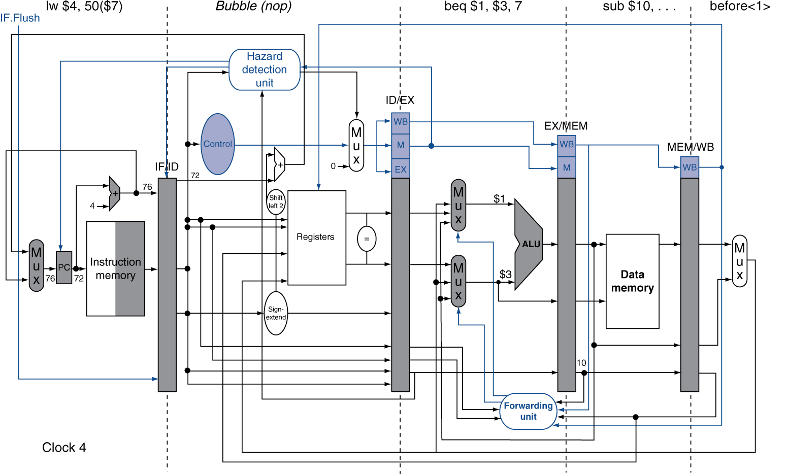

Examine the diagram, refer to your textbook and lecture notes, and explain how the forwarding unit and hazard detection units work:

